**Steps to create new .Net core API project from Template**

Open VS 2019 and click on Continue without code

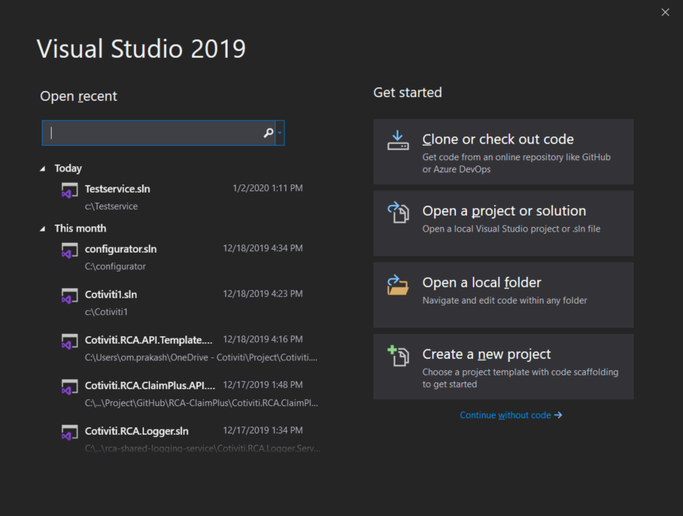

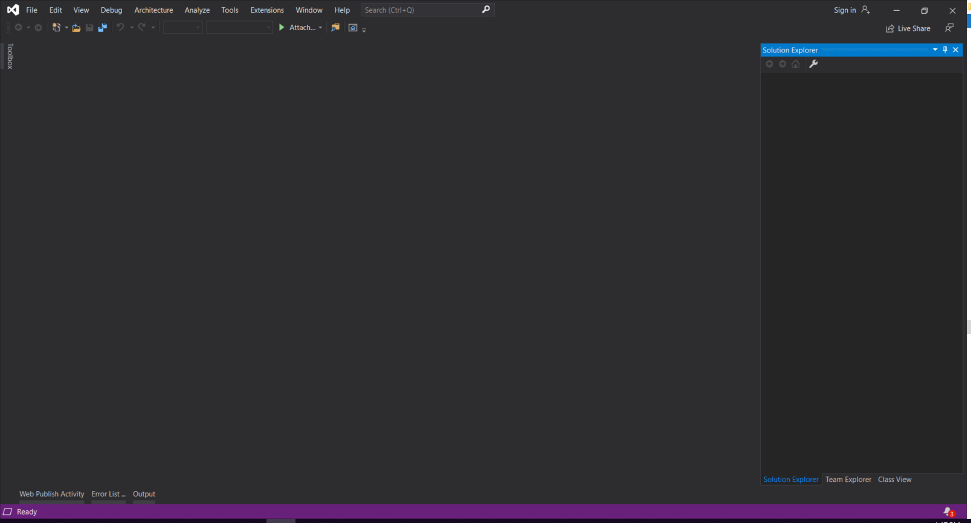

Click on Tools 🡪 Options

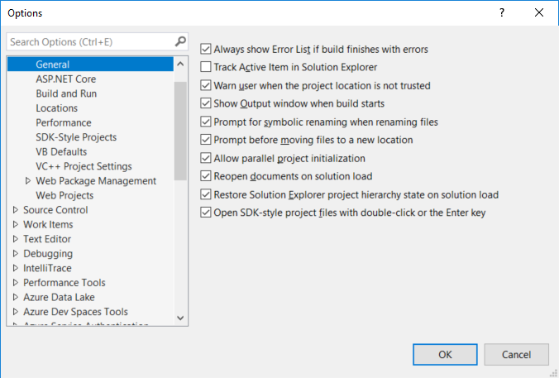

Click on Projects and Solutions 🡪 Locations

Update the user project templates location mentioned below.

\\ccaintranet.com\dfs-dc-01\DataProcessing\Teams\YMProductSupport\Projects\API Project Template\Template

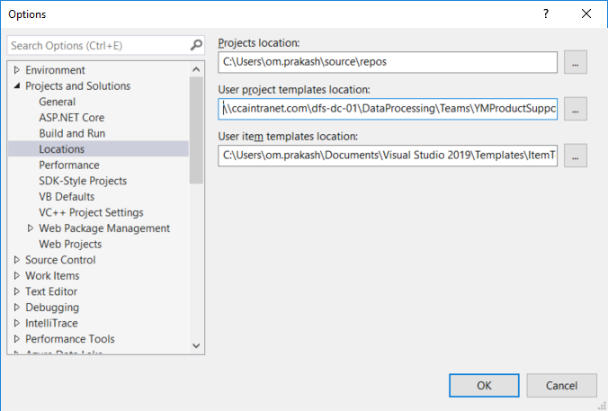

Now, create new project and select the Cotiviti.RCA.API.Template from the drop down

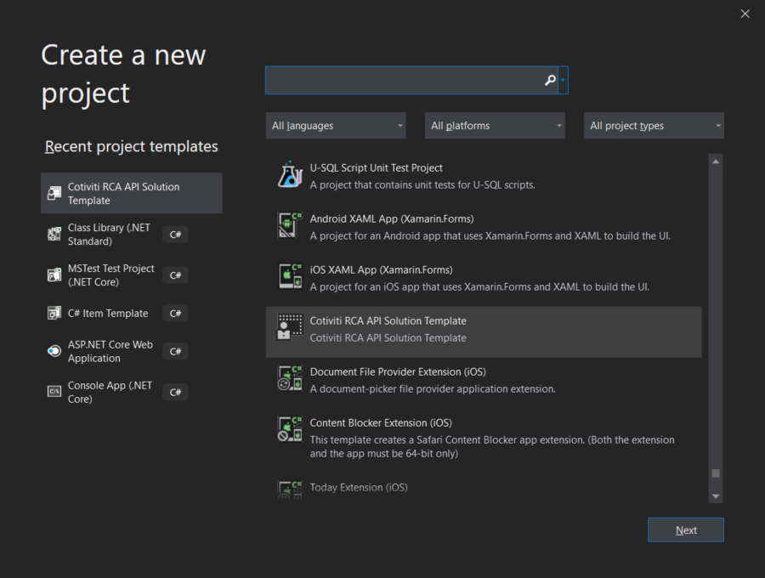

Update the ApplicationName key in appsettings file accordingly.

